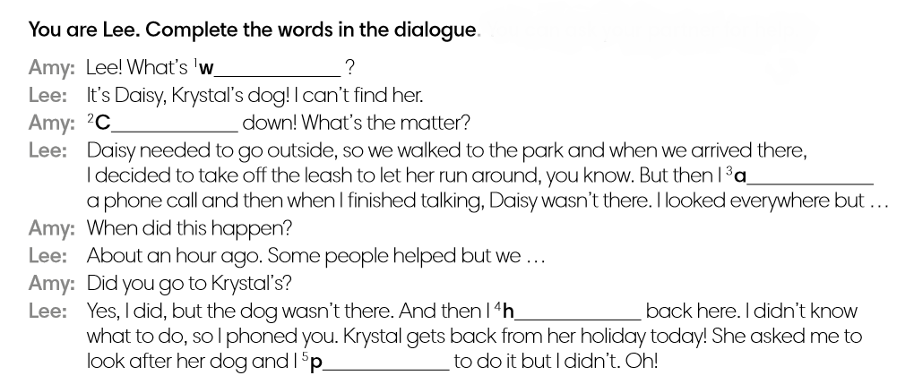
1.

2. If you are nor sure, choose the right words from here:
happened, hurried, answer, answered, protected, promised, wrong, worried, carry, calm

3. What happened in the end? Finish the story.

